Getting Started with download MPD3

- Download MPD3 from http://bioinform.info/
- Extract file and open file in MS Access. (2003 or any higher version)
- Main screen will look like this. On the left side you can see 4 types of search options, all of these options are explained in latter steps.
- Search By Activity by plant
- Search by Activity
- Search by Target
- Search Phytochemicals by Plants



Search Activity_by_Plant:
On the left side the first option is SEARCH ACTIVITY_by_Plant, this search option facilitates to find all activities possessed by your specified plant name. List of Available Plant Names in MPD3 is provided in Supplementary files. Please use those Plant names available as keywords for effective and quick output results.
Below are snapshots who guides you how to use this search option
(Example “Manihot esculenta”)
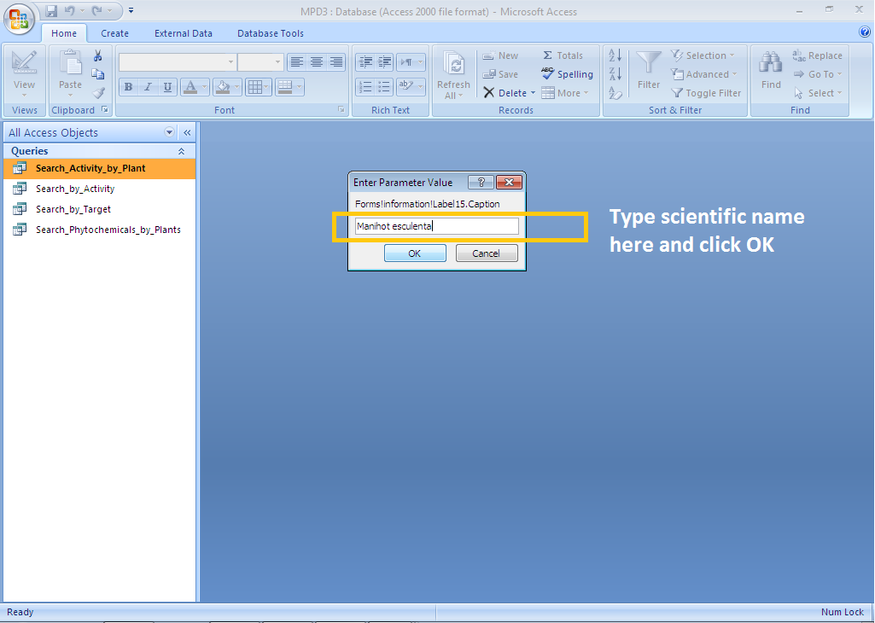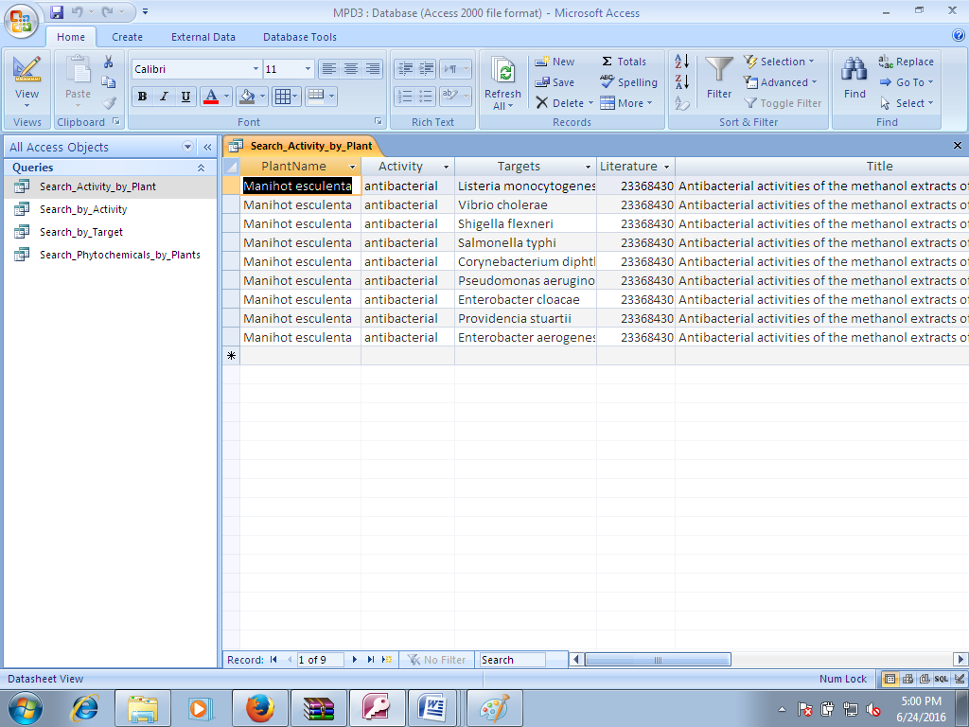

OUTPUT
Search by Activity:
On the left side the first option is SEARCH BY ACTIVITY, this search option facilitates to find all plants who have your specified activity. List of Available Activities in MPD3 is provided in Supplementary files. Please use those keywords for effective and quick output results.
Below are snapshots who guides you how to use this search option



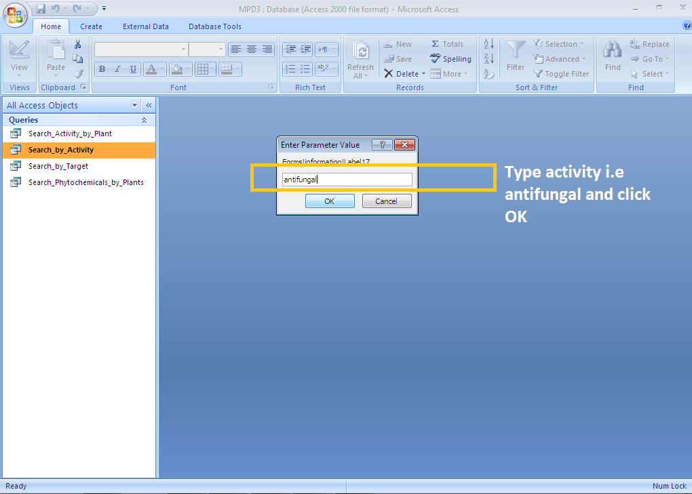

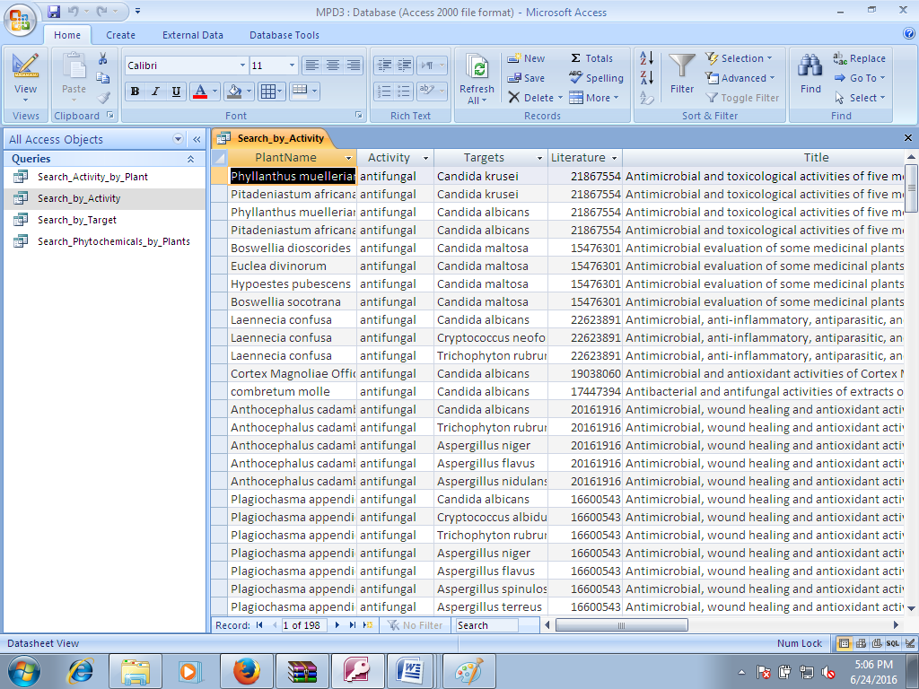

Search by Target:
On the left side the first option is SEARCH by Target, this search option facilitates to find all plants who possessed potential activity against your specified Target Name. they may be bacteria, viruses, fungi, insects, cancer and so on. List of Available Targets in MPD3 is provided in Supplementary files. Please use those target available as keywords for effective and quick output results.
Below are snapshots who guides you how to use this search option
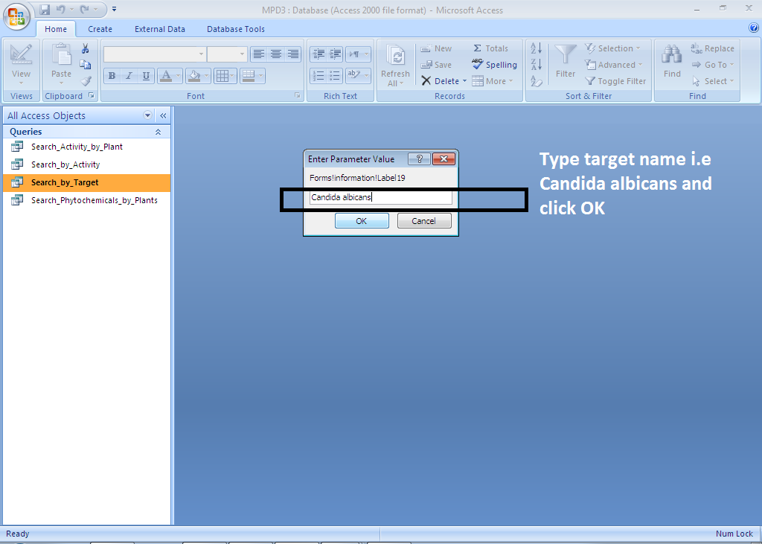

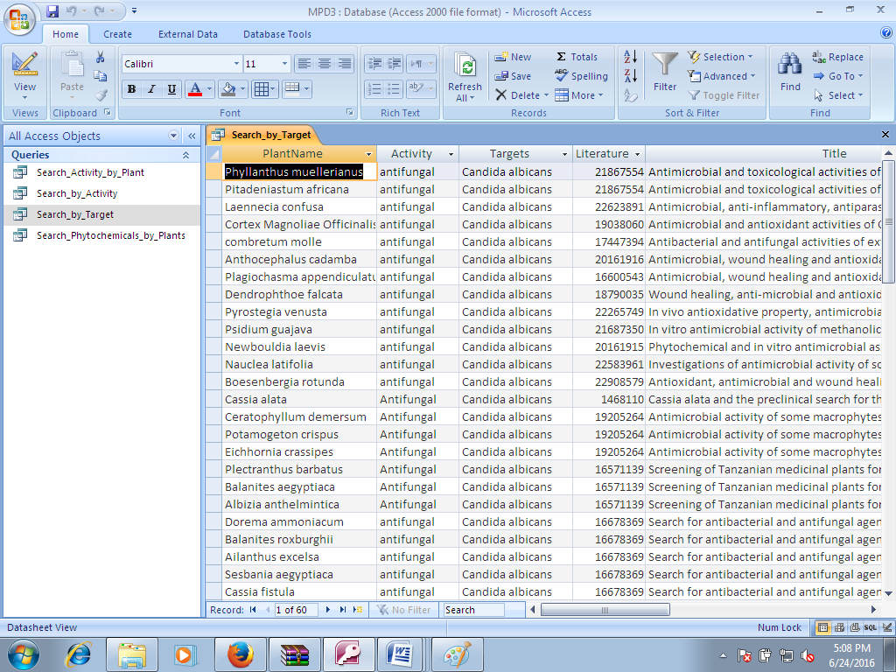

Search by Phytochemicals by Plants:
On the left side the first option is SEARCH Phytochemicals by plant, this search option facilitates to find all phytochemicals for your specified plant Name. They may be Saponins, Flavoniods, Alkaliods and so on. List of Available Plants in MPD3 is provided in Supplementary files. Please use those target available as keywords for effective and quick output results.
Below are snapshots who guides you how to use this search option
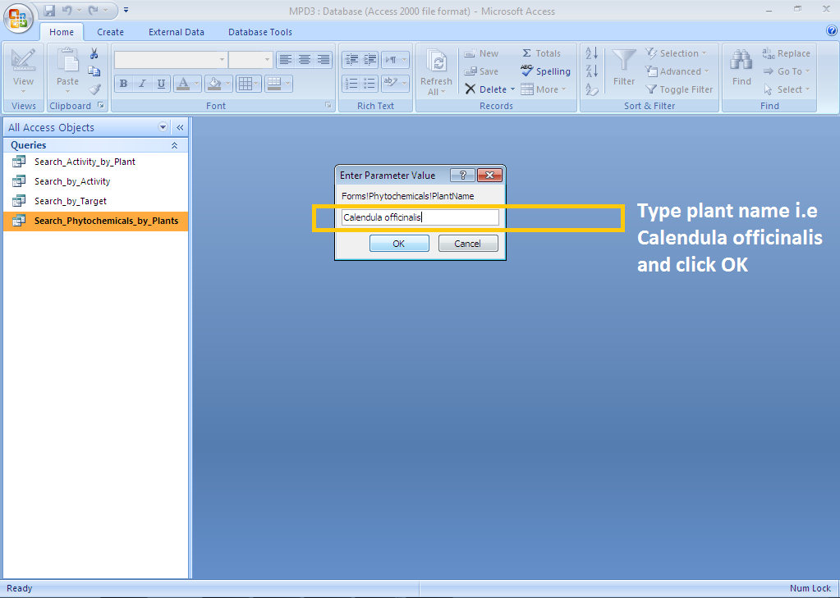

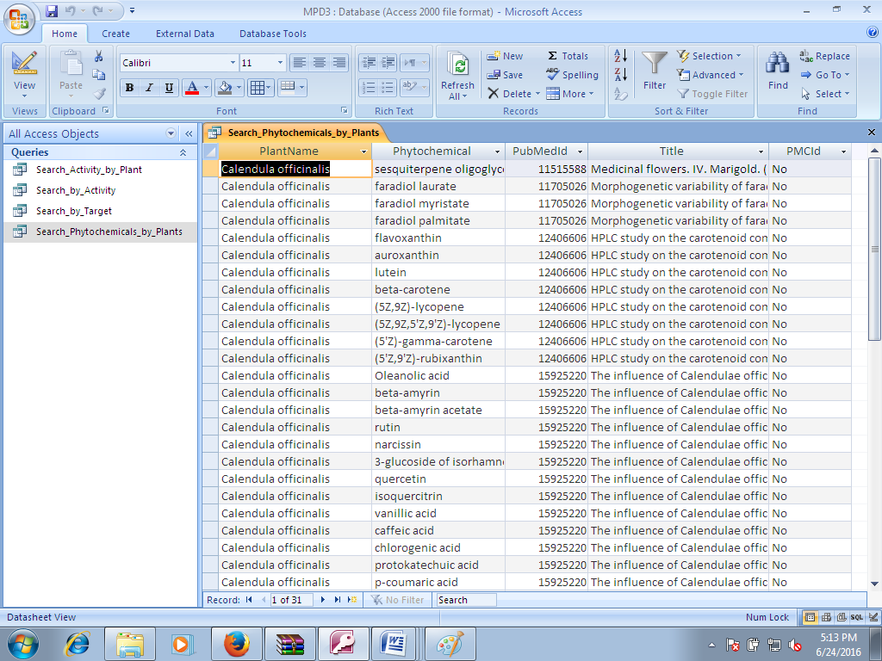

How to view results in Browser
Using MS Access default options for exporting query results you can view your results in browsers. Below are snapshots on how to export results in browers.

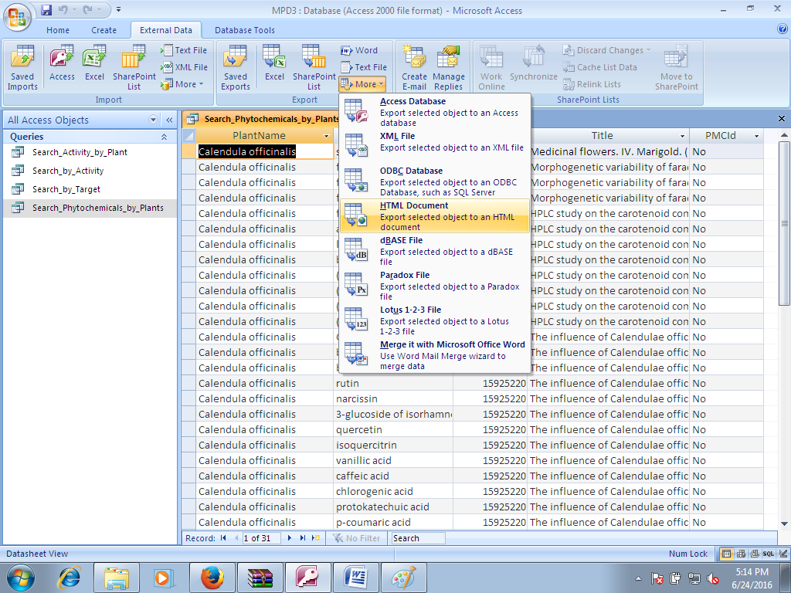

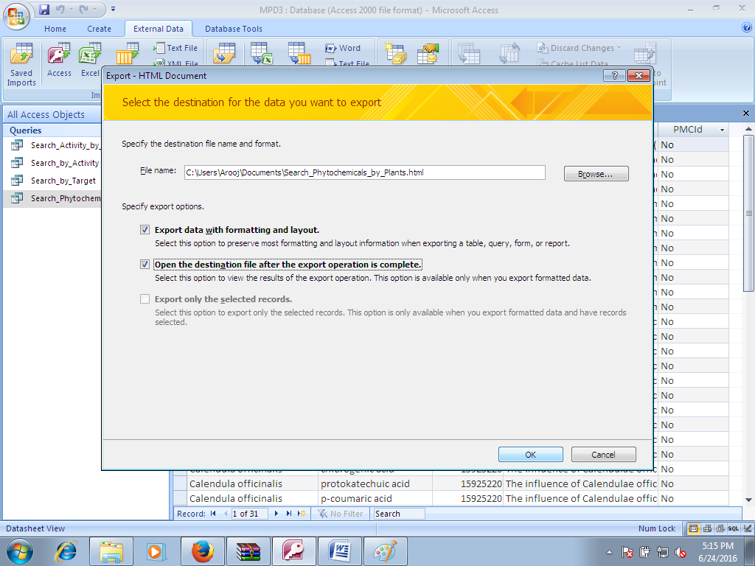

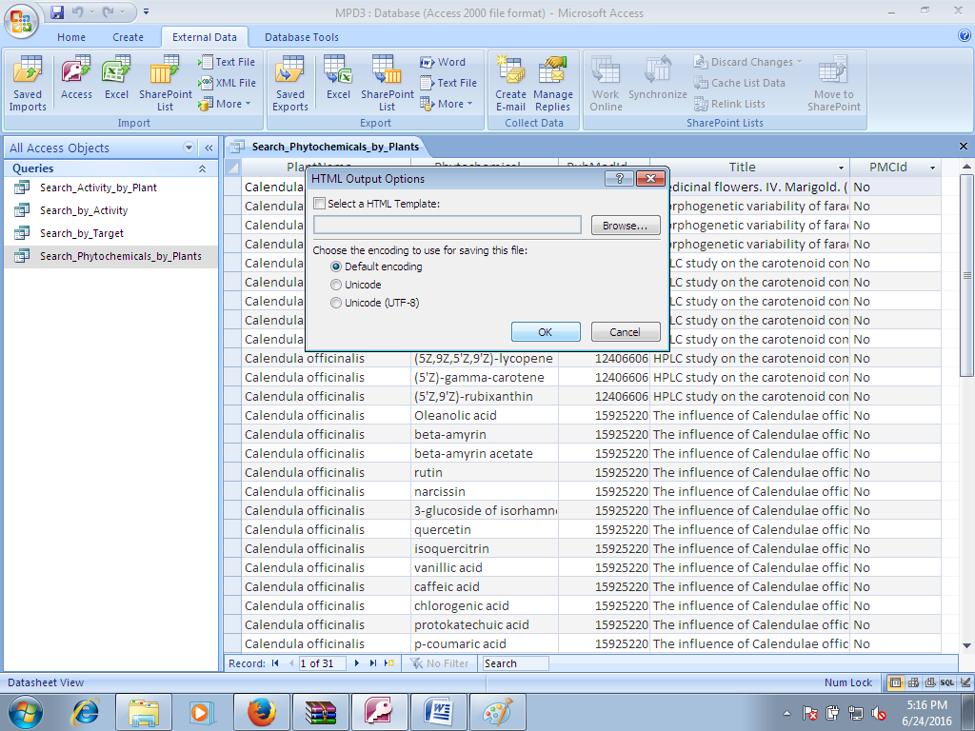

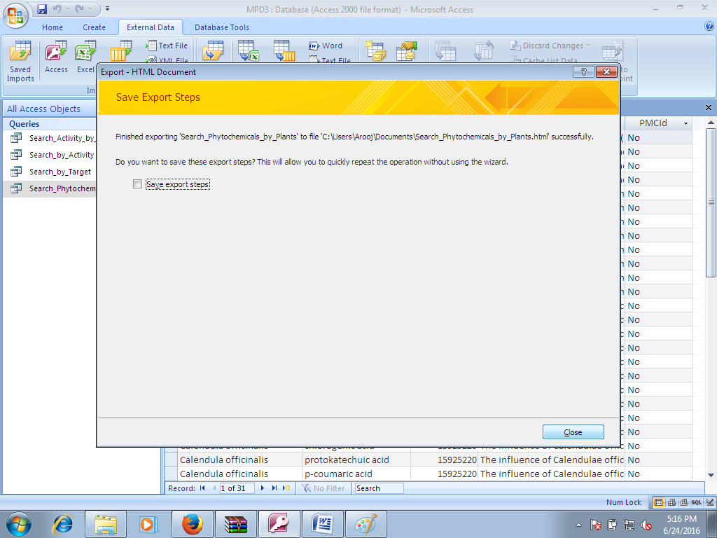

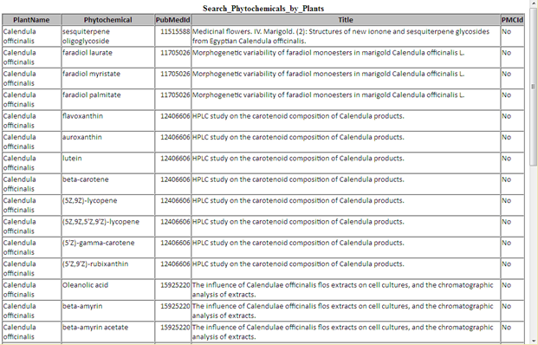

THANKS YOU

